# Analysis Report for not emotional, static conversation.docx

not emotional, static conversation.docx Analysis Report:  
---------------------  
affective_score: 2.14  
animate_score: 8.55  
commonality_score: 57.88  
cognitive_score: 0.00  
directness_score: 100.00  
dynamic_score: 2.04  
formality_score: 40.26  
generic_score: 30.00  
inanimate_score: 1.28  
individual_score: 9.49  
informality_score: 0.04  
intentional_score: 100.00  
longterm_score: 40.00  
negative_score: 0.00  
novelty_score: 0.32  
objectivity_score: 31.11  
place_score: 1.88  
politeness_score: 100.00  
Positive: 0.00  
qualitative_score: 100.00  
quantitative_score: 0.51  
short_term_score: 0.21  
social_score: 0.38  
specific_score: 0.00  
static_score: 0.00  
temporal_score: 0.43  
  
## Synergy Analysis:  
**Warning:** Missing dimension scores for Affective, Cognitive, Dynamic, Social, Novelty, Time, Negative, Intentionality, Formality, Specific, Static, Quantitative, Politeness. Synergy analysis may be incomplete.  
Overall Interpretation:  
The text shows strong indications in the following dimensions:  
- directness_score (Score: 100.00)  
- intentional_score (Score: 100.00)  
- politeness_score (Score: 100.00)  
  
The text shows weaker indications in the following dimensions:  
- Positive (Score: 0.00)  
- specific_score (Score: 0.00)  
- static_score (Score: 0.00)  
  
Analysis Method Used: Standard  
Interpretations are based on the dimension scores calculated using the selected method.

## Radar Chart for This Input

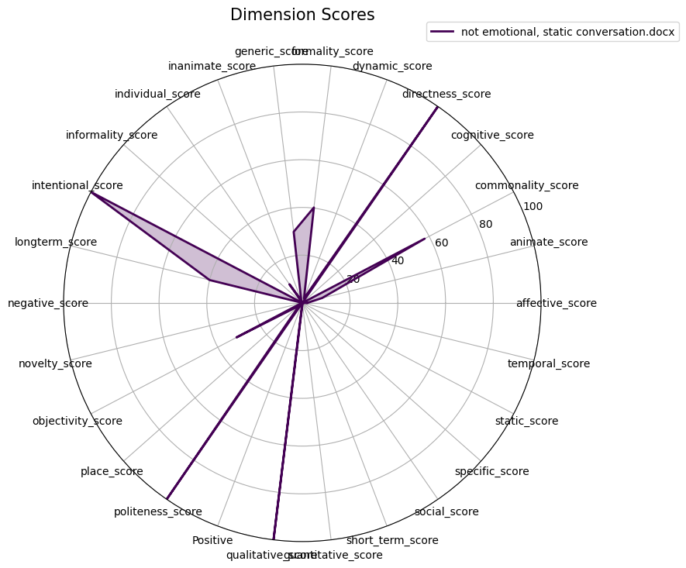

## Combined Radar Chart for All Inputs

